# 3.2

(a) Z > -1.13

The percent of Z < -1.13 in the normal probability table is 0.1292. So the percent of Z > -1.13 is (1-0.1292) = 0.8708 = 87.08%.

In R:

> install.packages("tigerstats")

> library("tigerstats", lib.loc="C:/Program Files for operation/R-3.3.1/library")

> pnormGC(-1.13, region="above", graph=TRUE)

[1] 0.8707619

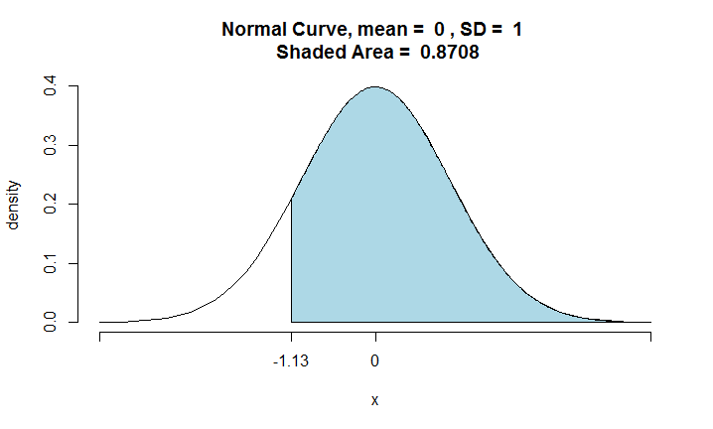

So the percent is 87.08%.

(b) Z < 0.18

The percent of Z < 0.18 in the normal probability table is 0.5714. So the percent is 57.14%.

In R:

> pnormGC(0.18, region="below", graph=TRUE)

[1] 0.5714237

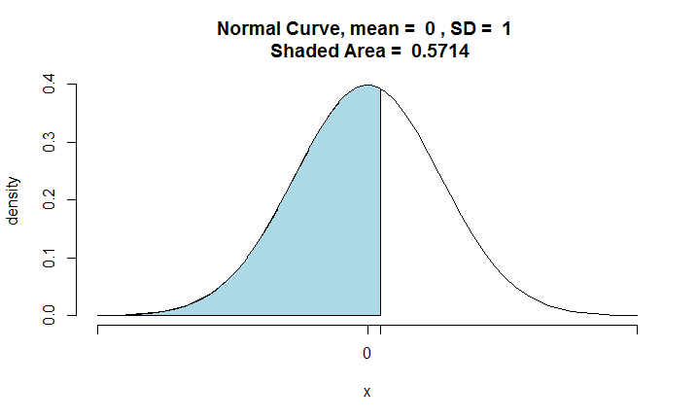

0.18

So the percent is 57.14%.

(c) Z > 8

The percent of Z < 3.5 in the normal probability table is greater than 0.9998. So the percent of Z > 8 is close to 0.

In R:

> pnormGC(8, region="above", graph=TRUE)

[1] 6.220961e-16

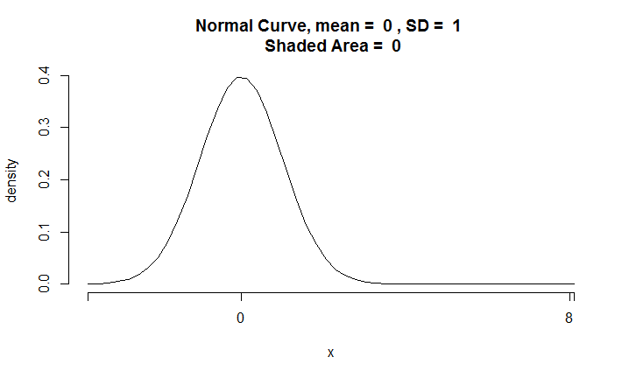

So the percent is 0.

(d) |Z| < 0.5

In R:

> pnormGC(bound = c(-0.5,0.5), region="between", graph=TRUE)

[1] 0.3829249

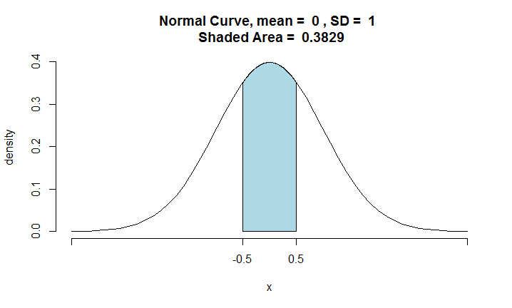

So the percent is 38.29%.

# 3.10

The distribution is , , .

(a)

> pnormGC(48, region="below", mean = 55, sd = 6, graph = TRUE)

[1] 0.1216725

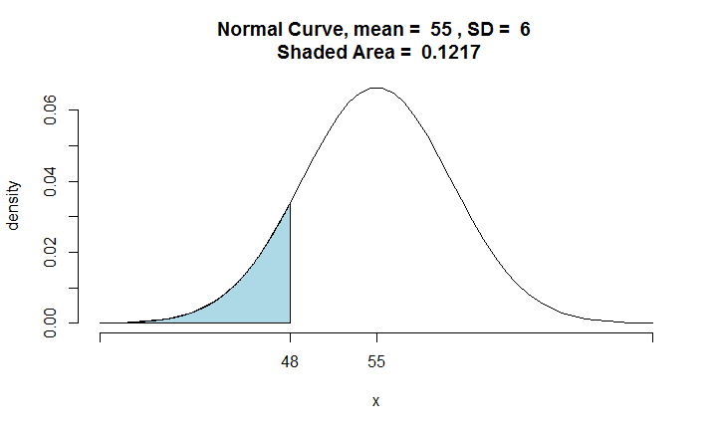

0.1217

So the probability of shorter than 48 inches is 12.17%.

(b)

> pnormGC(bound = c(60,65), region="between", mean = 55, sd = 6, graph = TRUE)

[1] 0.154538

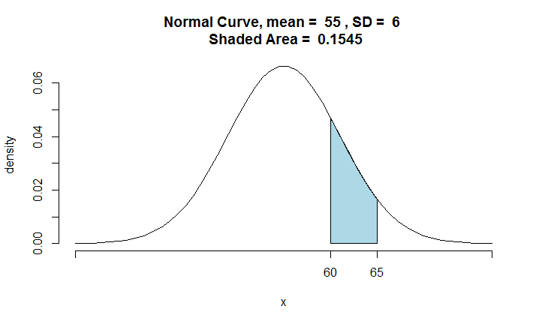

0.154538

> pnormGC(60, region = "below", mean = 55, sd = 6)

[1] 0.7976716

> pnormGC(65, region = "above", mean = 55, sd = 6)

[1] 0.04779035

, 



The probability of between 60 and 65 is 15.45%.

(c)

> qnorm(0.9, mean = 55, sd = 6)

[1] 62.68931

The height cutoff for very tall is 62.69 inches.

(d)

> pnormGC(54, region = "below", mean = 55, sd = 6)

[1] 0.4338162



So 43.38 percent of 10 year olds cannot go on this ride.

# 3.12

The distribution is , , .

(a)

> pnormGC(80, region = "below", mean = 72.6, sd = 4.78)

[1] 0.939203



So 93.92% of passenger vehicles travel slower than 80 miles/hour.

(b)

> pnormGC(c(60,80), region = "between", mean = 72.6, sd = 4.78)

[1] 0.9350083





So 93.5% of passenger vehicles travel between 60 and 80 miles/hour.

(c)

> qnorm(0.95, mean = 72.6, sd = 4.78)

[1] 80.4624

The fastest 5% of passenger vehicles travel greater than 80.4624 miles/hour.

(d)

> pnormGC(70, region = "above", mean = 72.6, sd = 4.78)

[1] 0.7067562

So 70.68% of passenger vehicles travel above the speed limit.

# 3.20

(a)

Probability of sampling two females in a row when sampling with replacement is .

Probability of sampling two females in a row when sampling without replacement is .

(b)

Probability of sampling two females in a row when sampling with replacement is = 0.25.

Probability of sampling two females in a row when sampling without replacement is .

(c)

For sampling with replacement, every time sampling an individual is an independent event because the sampling result of each time does not affect each other. But for sampling without replacement, sampling individuals are not independent because the last sampling result can affect the next sampling event, in other words, .

As can be seen from (a) and (b), when the population is small, the probability of sampling with and without replacement are different. But when the population is very large, there is hardly any difference between sampling with and without replacement. In other words, sampling two females with replacement in a row has little difference from sampling without replacement. In this case, , just like (b). So the assumption that we often treat individuals who are sampled from a large population as independent is reasonable. The critical condition is a large population compared to the sample size.

# 3.26

(a)

Using binomial distribution is appropriate: (1) Independent trials: In a random sample, whether or not one American adult had chickenpox during childhood does not depend on whether or not another one had. (2) Fixed number of trials: n = 100. (3) Only two outcomes at each trial: Had chickenpox or not. (4) Probability of a success is the same for each trial: p = 0.9.

(b)



(c)

Exactly 3 out of 100 adults have not had chickenpox in their childhood means that exactly 97 out of 100 adults had chickenpox. So the probability is the same as question (b). P = 0.59%

(d)



The probability of at least 1 out of 10 adults have had chickenpox is 99.9%, approximately to 100%.

(e)

The case that at most 3 out of 10 randomly sampled American adults have not had chickenpox is equal to the case that 7,8,9 or 10 out of 10 adults have had chickenpox.



So the probability is 98.7%.

# 3.28



(a)





I expect 108 out of 120 adults have had chickenpox in their childhood with the standard deviation of 3.286.

(b)

I would not be surprised if there were 105 people who have had chickenpox in their childhood. Because , 105 is within one standard deviation away from the mean. We can assume that it is a usual observation.

(c)

> pbinom(105, size = 120, prob = 0.9)

[1] 0.2181634

The probability is 21.8%. This number is not very small so for 105 people in question (b), it is not surprising.

# 3.30

This is a binomial distribution. 

, 



So 1500 is far more than 3 standard deviation away from the mean.

In R:

> pbinomGC(1500, region = "above", size = 15000, prob = 0.09)

[1] 1.173433e-05

The probability that at least 1500 will respond is approximately 0.

# 3.36

(a)

For each question, , 



So the probability that the first question she gets right is the 3rd question is .

(b)

This is a binomial distribution.



So the probability that she gets exactly 3 or exactly 4 questions right is 10.25%.

(c)



So the probability that she gets the majority of the questions right is 10.35%.